**/*Roll No : 3002**

**Program Name : Write a program to create login page. */**

**Defualt.aspx :-**

<%@ Page Language="C#" AutoEventWireup="true" CodeFile="Default.aspx.cs" Inherits="_Default" %>

<!DOCTYPE html PUBLIC "-//W3C//DTD XHTML 1.0 Transitional//EN" "http://www.w3.org/TR/xhtml1/DTD/xhtml1-transitional.dtd">

<html xmlns="http://www.w3.org/1999/xhtml">

<head runat="server">

<title>Untitled Page</title>

</head>

<body>

<form id="form1" runat="server">

<div>

<asp:Label ID="Label1" runat="server" Text="User Name"></asp:Label>

<asp:TextBox ID="TextBox1" runat="server"></asp:TextBox>

<asp:Label ID="Label2" runat="server" Text="Password"></asp:Label>

<asp:TextBox ID="TextBox2" runat="server" TextMode="Password"></asp:TextBox>

<p>

<asp:Button ID="Button1" runat="server" onclick="Button1_Click" Text="Submit" />

</p>

<p>

<asp:Label ID="Label3" runat="server" Text="Label"></asp:Label>

</p>

</div>

</form>

</body>

</html>

**Defualt.aspx.cs :-**

using System;

using System.Configuration;

using System.Data;

using System.Web;

using System.Web.Security;

using System.Web.UI;

using System.Web.UI.HtmlControls;

using System.Web.UI.WebControls;

using System.Web.UI.WebControls.WebParts;

public partial class _Default : System.Web.UI.Page

{

protected void Page_Load(object sender, EventArgs e)

{

}

protected void Button1_Click(object sender, EventArgs e)

{

Label3.Text = "LOGIN SUCCESSFULLY";

}

}

**Output :-**

**1}Starting Page :-**

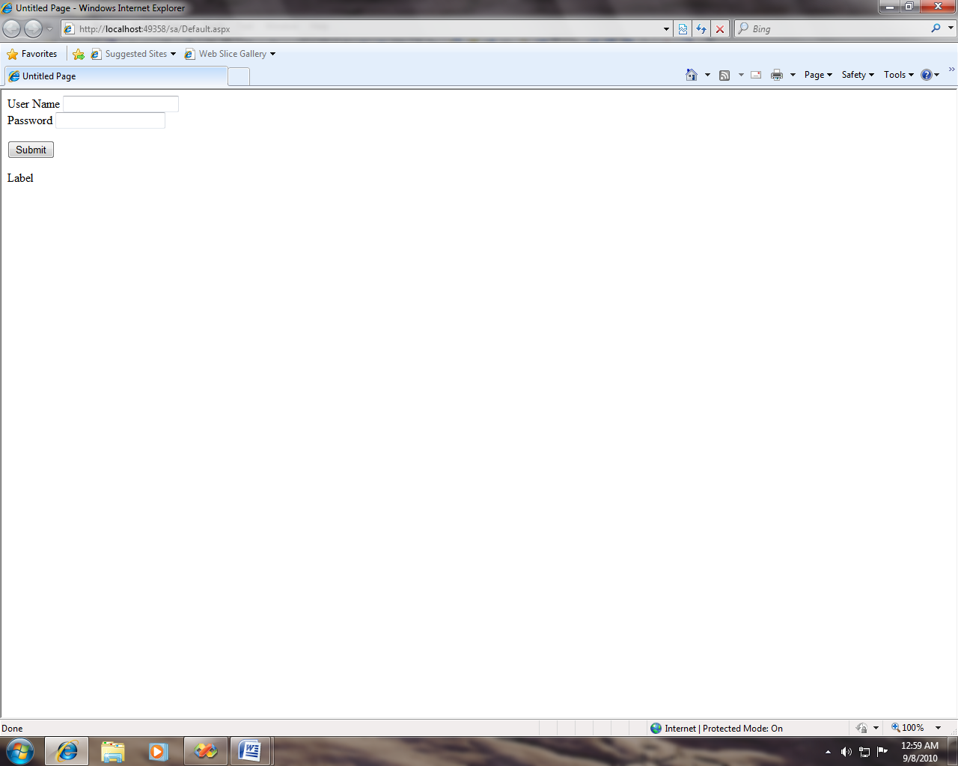

**2} After Clicking Submit :-**

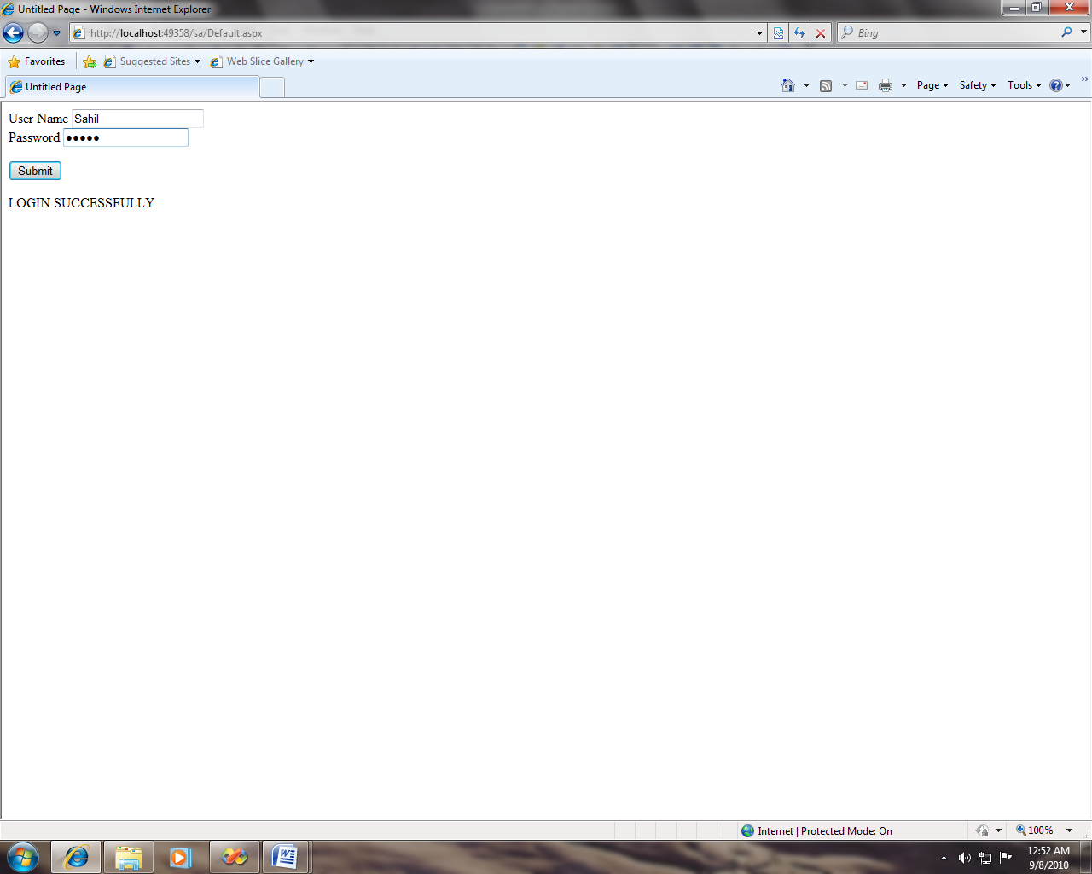

**/*Roll No : 3002**

**Program Name : Write a program to addition of two numbers. */**

**Defualt.aspx :-**

<%@ Page Language="C#" AutoEventWireup="true" CodeFile="Default.aspx.cs" Inherits="_Default" %>

<!DOCTYPE html PUBLIC "-//W3C//DTD XHTML 1.0 Transitional//EN" "http://www.w3.org/TR/xhtml1/DTD/xhtml1-transitional.dtd">

<html xmlns="http://www.w3.org/1999/xhtml">

<head runat="server">

<title>Untitled Page</title>

</head>

<body>

<form id="form1" runat="server">

<div>

<asp:Label ID="Label1" runat="server" Text="Enter A"></asp:Label>

<asp:TextBox ID="TextBox1" runat="server" ontextchanged="TextBox1_TextChanged"></asp:TextBox>

<br />

<asp:Label ID="Label2" runat="server" Text="Enter B"></asp:Label>

<asp:TextBox ID="TextBox2" runat="server"></asp:TextBox>

<br />

<asp:Button ID="Button1" runat="server" onclientclick="Button Click"

Text="Addition" />

<br />

<asp:Label ID="Label3" runat="server" Text="Addition"></asp:Label>

<asp:TextBox ID="TextBox3" runat="server"></asp:TextBox>

</div>

</form>

</body>

</html>

**Defualt.aspx.cs :-**

using System;

using System.Configuration;

using System.Data;

using System.Web;

using System.Web.Security;

using System.Web.UI;

using System.Web.UI.HtmlControls;

using System.Web.UI.WebControls;

using System.Web.UI.WebControls.WebParts;

public partial class _Default : System.Web.UI.Page

{

protected void Page_Load(object sender, EventArgs e)

{

}

protected void TextBox1_TextChanged(object sender, EventArgs e)

{

int a = Convert.ToInt32(TextBox1.Text);

int b = Convert.ToInt32(TextBox2.Text);

int add = (a + b);

TextBox3.Text = add.ToString();

}

}

**Output :-**

**1}Starting Page:-**

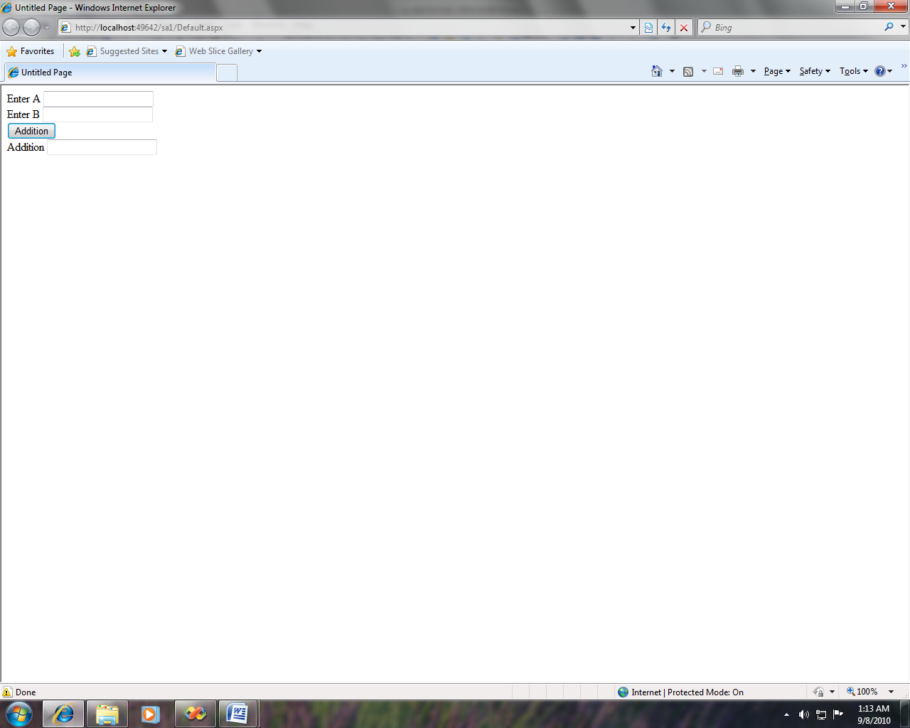

**2}After Clicking Addition:-**

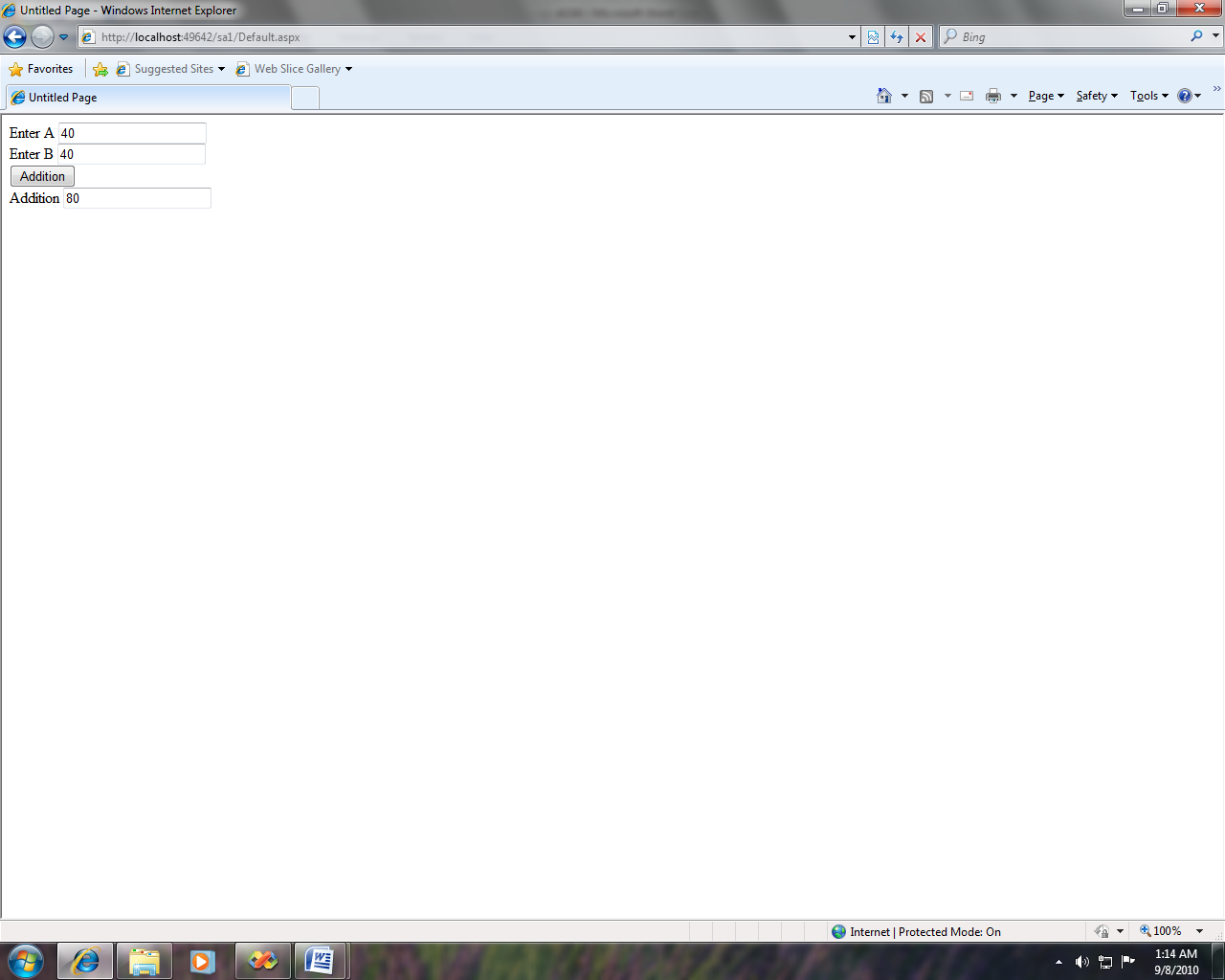

**/*Roll No : 3002**

**Program Name : Write a program to demonstrate the Button Control &**

**Hidden Field. */**

**Defualt.aspx :-**

<%@ Page Language="C#" AutoEventWireup="true" CodeFile="Default.aspx.cs" Inherits="_Default" %>

<!DOCTYPE html PUBLIC "-//W3C//DTD XHTML 1.0 Transitional//EN" "http://www.w3.org/TR/xhtml1/DTD/xhtml1-transitional.dtd">

<html xmlns="http://www.w3.org/1999/xhtml">

<head runat="server">

<title>Untitled Page</title>

</head>

<body>

<form id="form1" runat="server">

<div>

<asp:Label ID="Label1" runat="server" Font-Bold="True" Font-Underline="True"

Text="Button control example showing text on button click event"></asp:Label>

</div>

<br />

<asp:Button ID="Button1" runat="server" Font-Bold="True"

onclick="Button1_Click" onclientclick="Button1"

Text="Click Me,I will welcome You !!!" />

<br />

<br />

<asp:Label ID="Label2" runat="server" Text="Label"></asp:Label>

<br />

<br />

<asp:Label ID="Label3" runat="server" Font-Bold="True" Font-Underline="True"

Text="Field Control Showing value on Button click"></asp:Label>

<br />

<br />

<asp:Button ID="Button2" runat="server" Font-Bold="True"

onclick="Button2_Click" onclientclick="Button2" Text="Click Me!!" />

<br />

<br />

<asp:Label ID="Label4" runat="server"></asp:Label>

<br />

<br />

<asp:HiddenField ID="HiddenField1" runat="server" />

<br />

</form>

</body>

</html>

**Defualt.aspx.cs :-**

using System;

using System.Configuration;

using System.Data;

using System.Web;

using System.Web.Security;

using System.Web.UI;

using System.Web.UI.HtmlControls;

using System.Web.UI.WebControls;

using System.Web.UI.WebControls.WebParts;

public partial class _Default : System.Web.UI.Page

{

protected void Page_Load(object sender, EventArgs e)

{

HiddenField1.Value = "Welcome to the world of ASP.NET 4.0";

}

protected void Button1_Click(object sender, EventArgs e)

{

Label2.Text = "Welcome to the world of ASP.NET 4.0";

}

protected void Button2_Click(object sender, EventArgs e)

{

Label4.Text = HiddenField1.Value;

}

}

**Output :-**

**1}Starting Page :-**

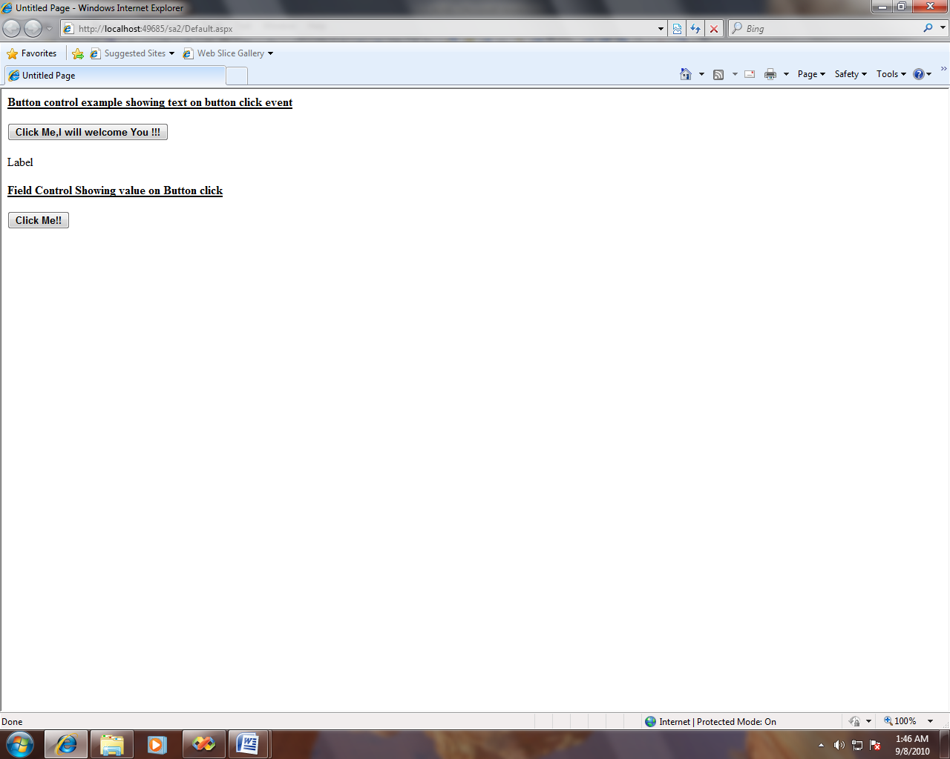

**2]After Clicking Click Me, I Will Welcome You!!!**

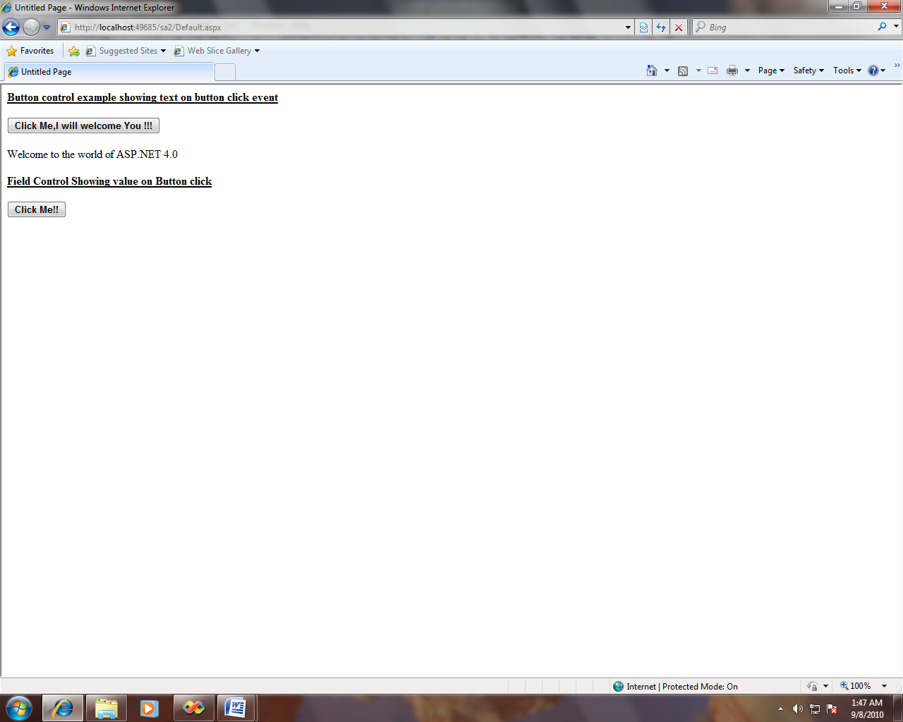

**3}After Clicking Click Me:-**

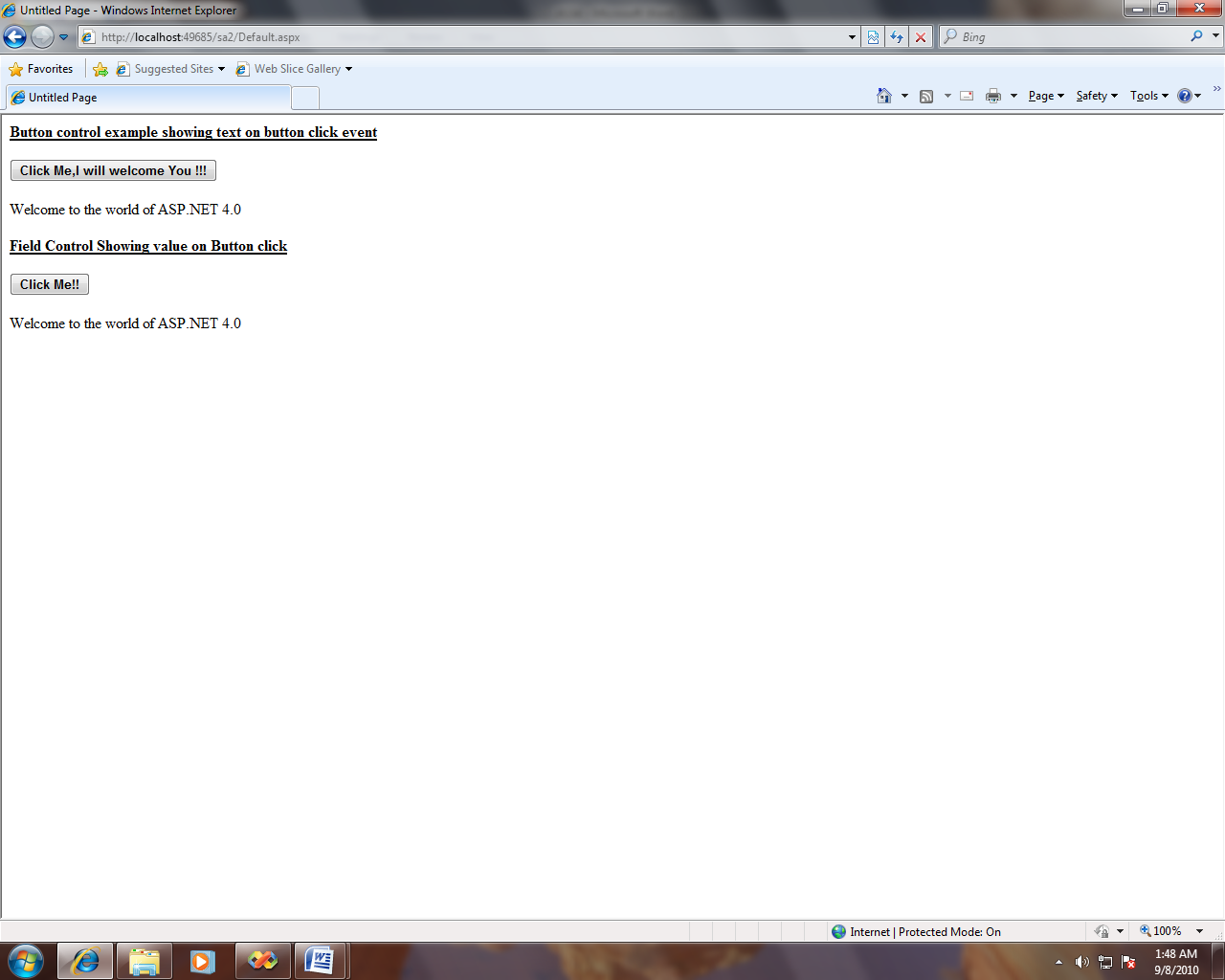

**/*Roll No : 3002**

**Program Name : Write a program to demonstrate the Image Control &**

**Image Button Control.*/**

**Defualt.aspx :-**

<form id="form1" runat="server">

<div>

<asp:Label ID="Label1" runat="server" Font-Bold="True" Font-Underline="True"

Text="Image Control Example"></asp:Label>

<br />

<br />

<asp:Button ID="Button1" runat="server" BackColor="#999966" Font-Bold="True"

ForeColor="Blue" onclientclick="Button1"

Text="Click me to view the image!!" onclick="Button1_Click" />

<br />

<br />

<asp:Image ID="Image1" runat="server" BorderColor="#CC0099" Height="239px"

ToolTip="Image control example" Visible="False" ImageUrl="~/Tulips.jpg" />

<br />

<br />

<asp:Label ID="Label2" runat="server" Font-Bold="True" Font-Underline="True"

Text="ImageButton Control Example"></asp:Label>

<br />

<br />

<asp:Label ID="Label3" runat="server" BorderWidth="2px" Font-Italic="True"

ForeColor="#CC0000" Text="Click Anywhere on the ImageButton control Below"></asp:Label>

<br />

<br />

<asp:ImageButton ID="ImageButton1" runat="server" Height="205px"

onclick="ImageButton1_Click" onclientclick="&quot;ImageButton1"

Width="284px" ImageUrl="~/Penguins.jpg" />

<br />

<br />

<asp:Label ID="Label4" runat="server"

Text="You clicked on the ImageButton at following co-ordinates"

BorderColor="#FF66CC" BorderStyle="Outset"></asp:Label>

<br />

<asp:Label ID="Label5" runat="server" BackColor="#CC99FF"></asp:Label>

</div>

</form>

**Defualt.aspx.cs :-**

using System;

using System.Configuration;

using System.Data;

using System.Web;

using System.Web.Security;

using System.Web.UI;

using System.Web.UI.HtmlControls;

using System.Web.UI.WebControls;

using System.Web.UI.WebControls.WebParts;

public partial class _Default : System.Web.UI.Page

{

protected void Page_Load(object sender, EventArgs e)

{

}

protected void Button1_Click(object sender, EventArgs e)

{

Image1.Visible = true;

}

protected void ImageButton1_Click(object sender, ImageClickEventArgs e)

{

Label5.Text = e.X.ToString() + " , " + e.Y.ToString();

}

}

**Output :-**

**1} Starting Page :-**

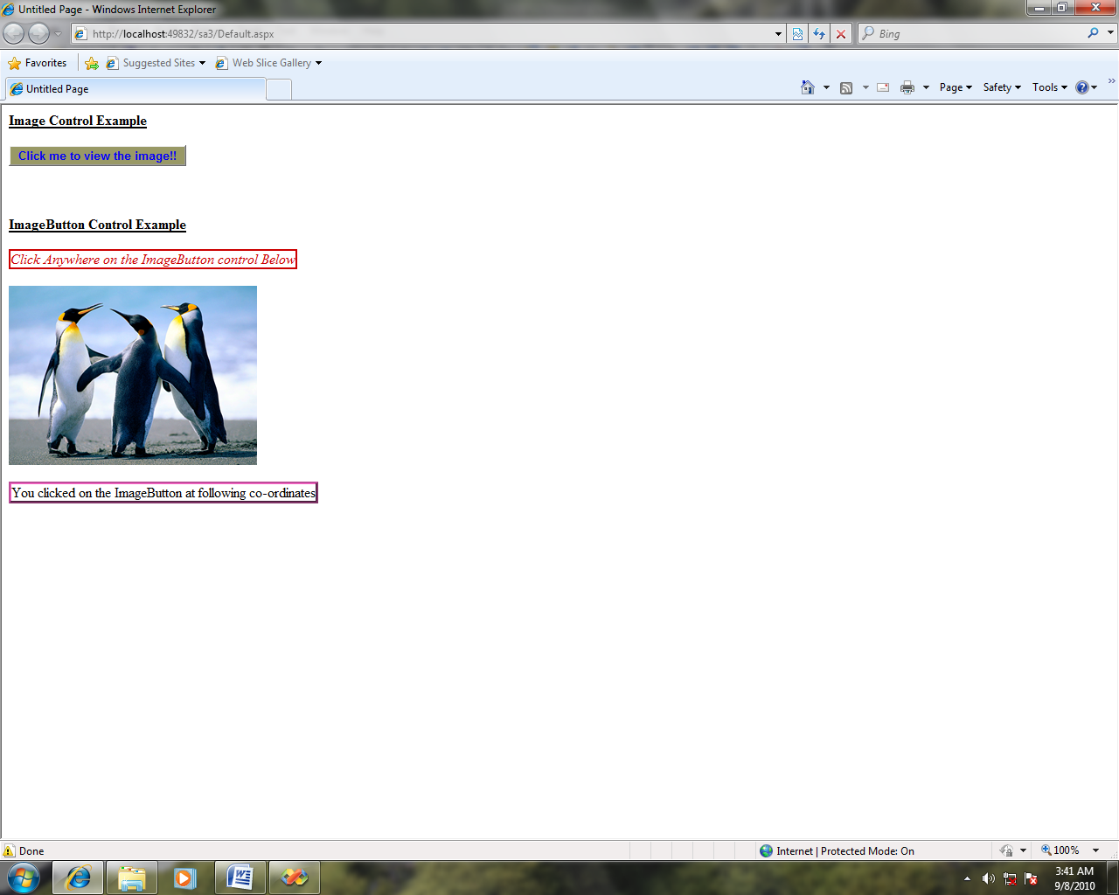

**2}After Clicking Click to view the image :-**

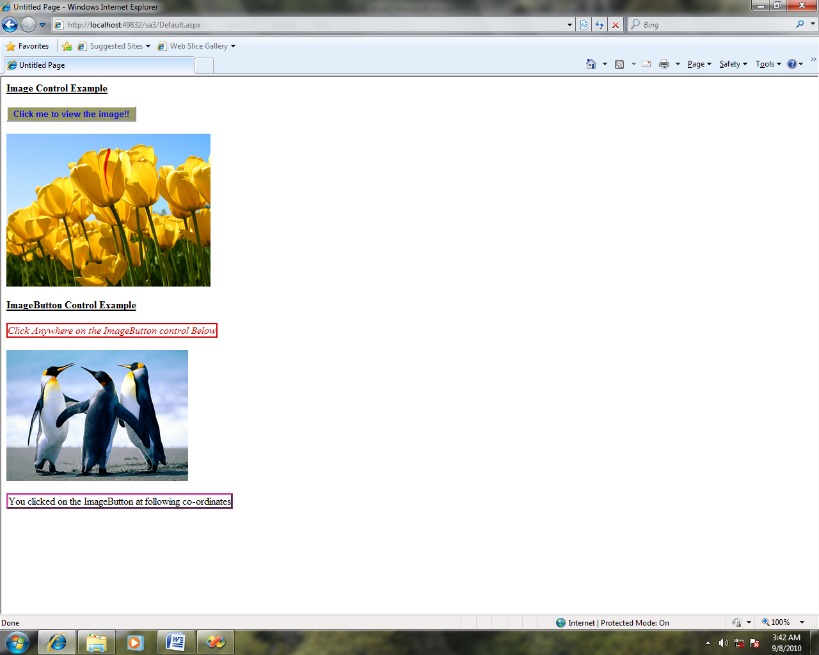

**3} After Clicking Image :-**

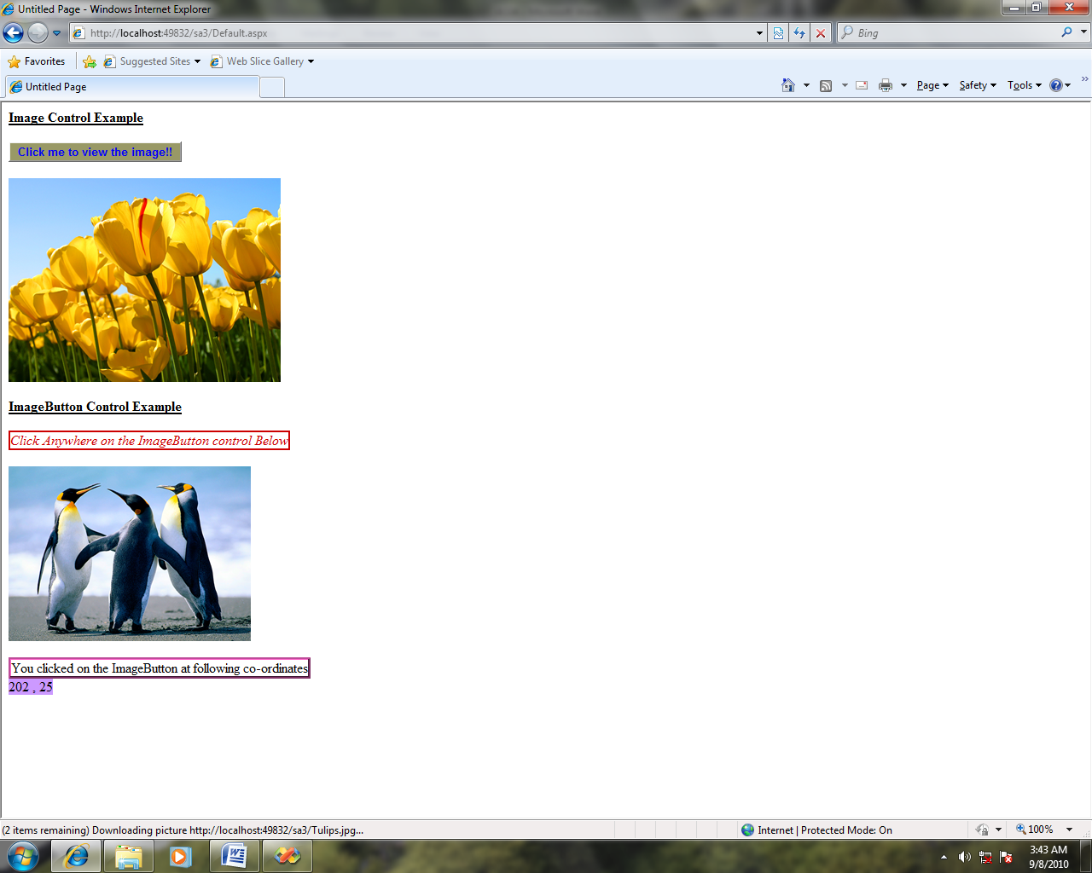

**/*Roll No : 3002**

**Program Name : Write a program to demonstrate the Listbox Control &**

**Dropdown list Control. */**

**DemoDropdownlist.aspx :-**

<%@ Page Language="C#" AutoEventWireup="true" CodeFile="DemoDropdownlist.aspx.cs" Inherits="DemoDropdownlist" %>

<!DOCTYPE html PUBLIC "-//W3C//DTD XHTML 1.0 Transitional//EN" "http://www.w3.org/TR/xhtml1/DTD/xhtml1-transitional.dtd">

<html xmlns="http://www.w3.org/1999/xhtml">

<head runat="server">

<title>Untitled Page</title>

</head>

<body>

<form id="form1" runat="server">

<div>

<asp:DropDownList ID="DropDownList1" runat="server">

<asp:ListItem>Red</asp:ListItem>

<asp:ListItem>Yellow</asp:ListItem>

<asp:ListItem>Green</asp:ListItem>

<asp:ListItem>Blue</asp:ListItem>

<asp:ListItem>Cyan</asp:ListItem>

</asp:DropDownList>

<br />

<asp:Button ID="Button1" runat="server" onclick="Button1_Click"

Text="Select Color" />

<br />

<asp:Label ID="Label1" runat="server" Font-Bold="True" Font-Size="X-Large"

Text="Jaysingpur College Jaysingpur"></asp:Label>

<br />

<br />

<asp:ListBox ID="ListBox1" runat="server"></asp:ListBox>

</div>

</form>

</body>

</html>

**DemoDropdownlist. aspx.cs :-**

using System;

using System.Collections;

using System.Configuration;

using System.Data;

using System.Linq;

using System.Web;

using System.Web.Security;

using System.Web.UI;

using System.Web.UI.HtmlControls;

using System.Web.UI.WebControls;

using System.Web.UI.WebControls.WebParts;

using System.Xml.Linq;

public partial class DemoDropdownlist : System.Web.UI.Page

{

protected void Page_Load(object sender, EventArgs e)

{

}

protected void Button1_Click(object sender, EventArgs e)

{

string c=DropDownList1.SelectedValue.ToString();

ListBox1.Items.Add(c);

if (c == "Red")

Label1.ForeColor = System.Drawing.Color.Red;

else if (c == "Yellow")

Label1.ForeColor = System.Drawing.Color.Yellow;

else if (c == "Green")

Label1.ForeColor = System.Drawing.Color.Green;

else if (c == "Cyan")

Label1.ForeColor = System.Drawing.Color.Cyan;

else if (c == "Blue")

Label1.ForeColor = System.Drawing.Color.Blue;

else

Label1.ForeColor = System.Drawing.Color.Black;

}

}

**Output :-**

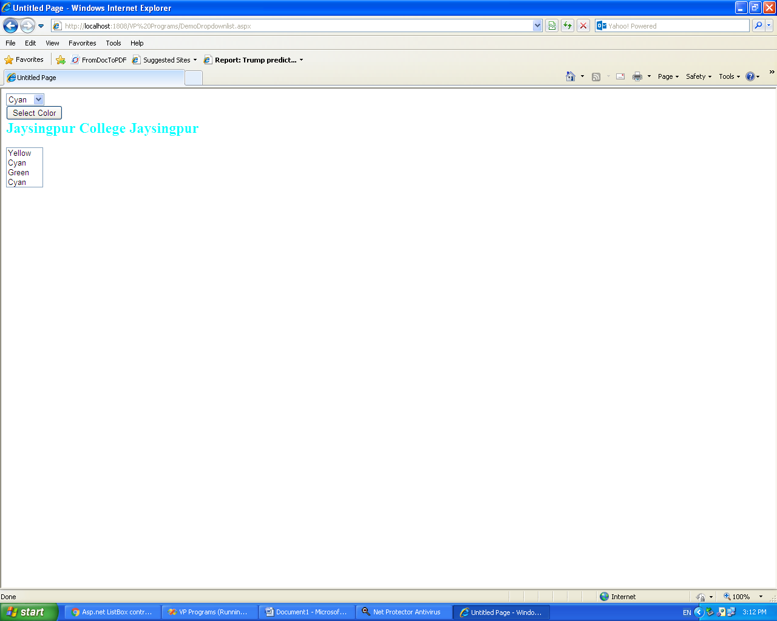

**/*Roll No : 3002**

**Program Name : Write a program to demonstrate Hyperlink & Link Button**

**Control. */**

**Defualt.aspx :-**

<%@ Page Language="C#" AutoEventWireup="true" CodeFile="Default.aspx.cs" Inherits="_Default" %>

<!DOCTYPE html PUBLIC "-//W3C//DTD XHTML 1.0 Transitional//EN" "http://www.w3.org/TR/xhtml1/DTD/xhtml1-transitional.dtd">

<html xmlns="http://www.w3.org/1999/xhtml">

<head runat="server">

<title>Untitled Page</title>

</head>

<body>

<form id="form1" runat="server">

<div>

<asp:Label ID="Label1" runat="server" Font-Bold="True" Font-Size="Medium"

Font-Underline="True" ForeColor="#FF66FF" Text="HyperLink control example"></asp:Label>

<br />

<br />

<asp:HyperLink ID="HyperLink1" runat="server" Font-Size="Small" ForeColor="Blue" Target="_blank" NavigateUrl="http:\\www.google.co.in">click me to move to the google website</asp:HyperLink>

<br />

<asp:Label ID="Label2" runat="server" font-bold="true" Font-Size="Medium" Font-Underline="true" ForeColor="Black" Text="LinkButton control example"></asp:Label>

<br />

<br />

<br />

<asp:LinkButton ID="LinkButton1" runat="server" BackColor="White" BorderColor="#00ccff" Font-Names="Tahoma" Font-Size="Small" ForeColor="#0000cc" OnClick="Linlbutton1_click" ToolTip="google website">LinkButton</asp:LinkButton>

</div>

</form>

</body>

</html>

**Defualt.aspx.cs :-**

using System;

using System.Configuration;

using System.Data;

using System.Linq;

using System.Web;

using System.Web.Security;

using System.Web.UI;

using System.Web.UI.HtmlControls;

using System.Web.UI.WebControls;

using System.Web.UI.WebControls.WebParts;

using System.Xml.Linq;

public partial class _Default : System.Web.UI.Page

{

protected void Page_Load(object sender, EventArgs e)

{

LinkButton1.Text = "click me to move to google website";

}

protected void Linlbutton1_click(object sender, EventArgs e)

{

Response.Redirect("http://www.google.co.in");

}

}

**Output :-**

**1}Strating Page :-**

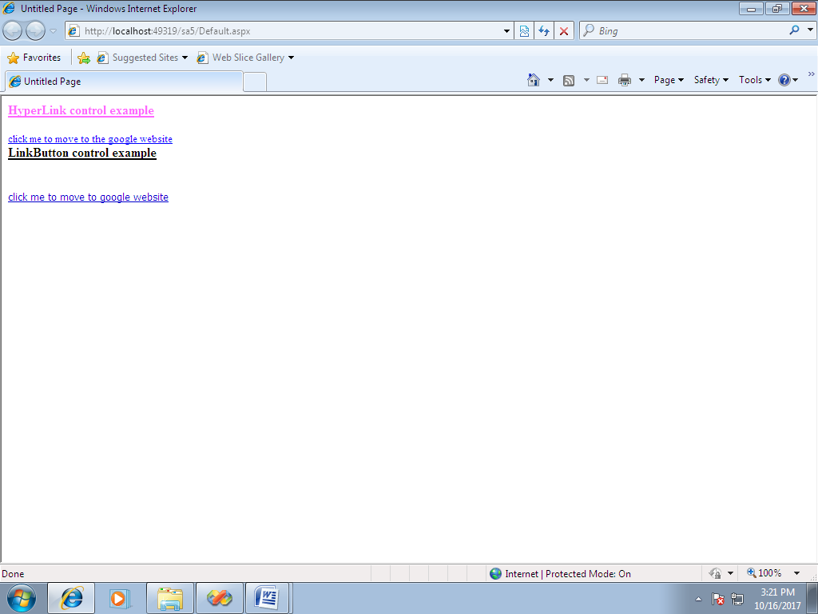

**2}After Cliking click me to move to the google website :-**

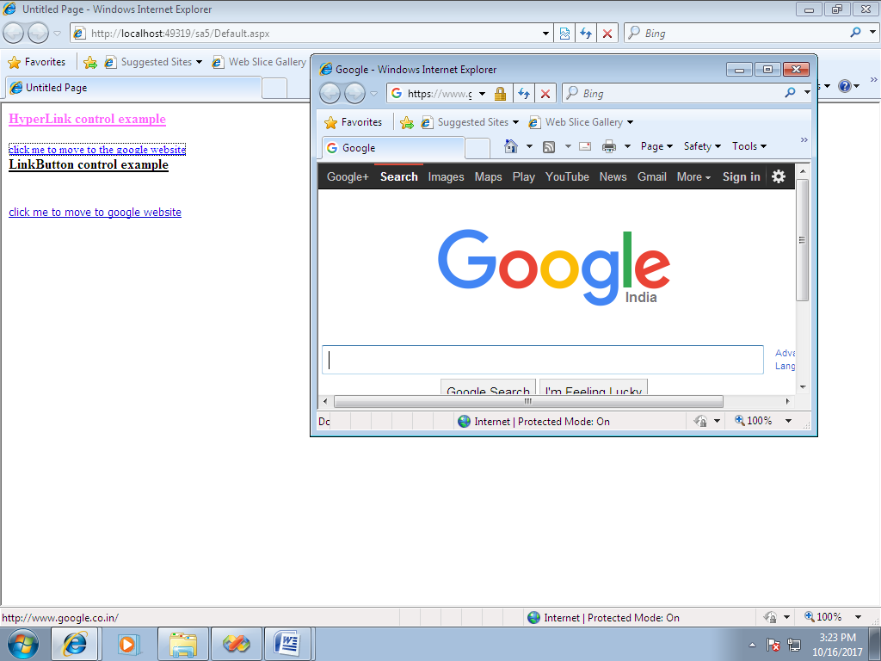

**3} After Clicking click me to move to google website:-**

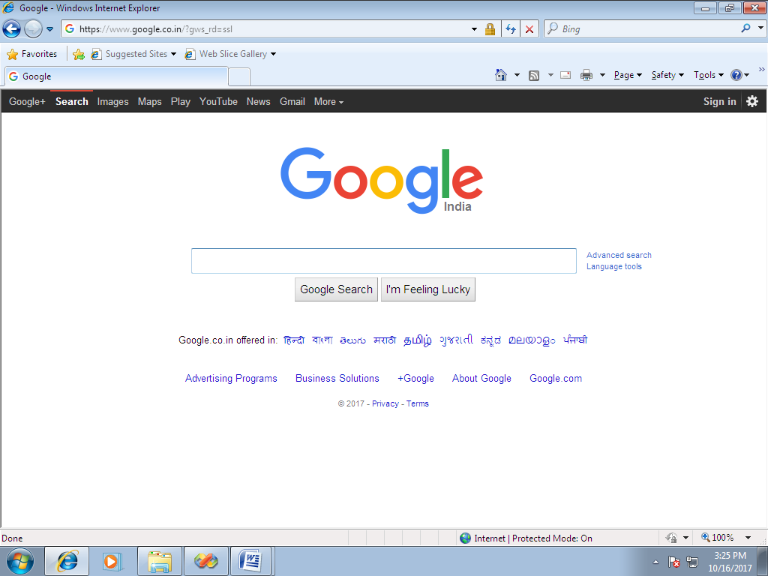

**/*Roll No : 3002**

**Program Name : Write a program to Check Box & Radio Button & Pannel.*/**

**Defualt.aspx :-**

<%@ Page Language="C#" AutoEventWireup="true" CodeFile="Default.aspx.cs" Inherits="_Default" %>

<!DOCTYPE html PUBLIC "-//W3C//DTD XHTML 1.0 Transitional//EN" "http://www.w3.org/TR/xhtml1/DTD/xhtml1-transitional.dtd">

<html xmlns="http://www.w3.org/1999/xhtml">

<head runat="server">

<title>Untitled Page</title>

</head>

<body>

<form id="form1" runat="server">

<div>

<asp:Label ID="Label1" runat="server" Font-Bold="True" Font-Size="Medium"

Font-Underline="True" Text="Check Box Example"></asp:Label>

<br />

<br />

<asp:Label ID="Label2" runat="server" Font-Size="Small" ForeColor="#FF33CC"

Text="Which of these cars you own"></asp:Label>

<br />

<br />

<asp:CheckBox ID="CheckBox1" runat="server" AutoPostBack="True"

Font-Size="Small" oncheckedchanged="CheckBox1_CheckedChanged1"

Text="Maruti Zen" />

<br />

<asp:CheckBox ID="CheckBox2" runat="server" AutoPostBack="True"

Font-Size="Small" oncheckedchanged="CheckBox2_CheckedChanged1"

Text="Honda City" />

<br />

<asp:CheckBox ID="CheckBox3" runat="server" AutoPostBack="True"

Font-Size="Small" oncheckedchanged="CheckBox3_CheckedChanged1"

Text="Toyata" />

<br />

<asp:ListBox ID="ListBox1" runat="server"></asp:ListBox>

<br />

<br />

<asp:Label ID="Label3" runat="server" Font-Bold="True" Font-Size="Medium"

Font-Underline="True" Text="Radio Button Control Example"></asp:Label>

<br />

<br />

<asp:Label ID="Label4" runat="server" Font-Size="Small" ForeColor="Red"

Text="Select the car you want buy"></asp:Label>

<br />

<br />

<asp:RadioButton ID="RadioButton1" runat="server" AutoPostBack="True"

Font-Size="Small" ForeColor="Fuchsia"

oncheckedchanged="RadioButton1_Checkedchanged" Text="Maruti Zen" />

<br />

<asp:RadioButton ID="RadioButton2" runat="server" AutoPostBack="True"

Font-Size="Small" ForeColor="Fuchsia"

oncheckedchanged="RadioButton2_Checkedchanged" Text="Toyato" />

<br />

<asp:RadioButton ID="RadioButton3" runat="server" AutoPostBack="True"

Font-Size="Small" ForeColor="Fuchsia"

oncheckedchanged="RadioButton3_Checkedchanged" Text="Maruti Esteem" />

<br />

<br />

<asp:Label ID="Label5" runat="server" Font-Size="Small" ForeColor="#CC00FF"

Text="Label"></asp:Label>

&nbsp;&nbsp;&nbsp;

</div>

</form>

</body>

</html>

**Defualt.aspx.cs :-**

using System;

using System.Configuration;

using System.Data;

using System.Linq;

using System.Web;

using System.Web.Security;

using System.Web.UI;

using System.Web.UI.HtmlControls;

using System.Web.UI.WebControls;

using System.Web.UI.WebControls.WebParts;

using System.Xml.Linq;

public partial class _Default : System.Web.UI.Page

{

protected void Page_Load(object sender, EventArgs e)

{

}

protected void Check(object sender, EventArgs e)

{

}

protected void CheckBox1_CheckedChanged1(object sender, EventArgs e)

{

if (CheckBox1.Checked == true)

{

ListBox1.Items.Add(CheckBox1.Text);

}

else

{

ListBox1.Items.Remove(ListBox1.Items.FindByText(CheckBox1.Text));

}

}

protected void CheckBox2_CheckedChanged1(object sender, EventArgs e)

{

if (CheckBox2.Checked == true)

{

ListBox1.Items.Add(CheckBox2.Text);

}

else

{

ListBox1.Items.Remove(ListBox1.Items.FindByText(CheckBox2.Text));

}

}

protected void CheckBox3_CheckedChanged1(object sender, EventArgs e)

{

if (CheckBox3.Checked == true)

{

ListBox1.Items.Add(CheckBox3.Text);

}

else

{

ListBox1.Items.Remove(ListBox1.Items.FindByText(CheckBox3.Text));

}

}

protected void RadioButton1_Checkedchanged(object sender, EventArgs e)

{

Label5.Text = "<font color=Black>You Have Selected;</font>" + RadioButton1.Text;

}

protected void RadioButton2_Checkedchanged(object sender, EventArgs e)

{

Label5.Text = "<font color=Black>You Have Selected;</font>" + RadioButton2.Text;

}

protected void RadioButton3_Checkedchanged(object sender, EventArgs e)

{

Label5.Text = "<font color=Black>You Have Selected;</font>" + RadioButton3.Text;

}

}

**Output :-**

**1}Strating Page :-**

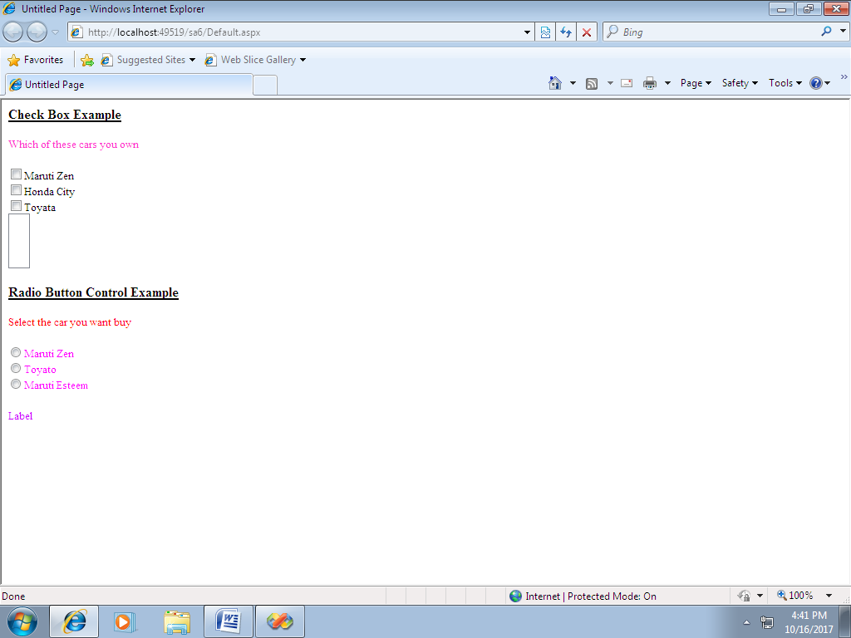

**2}After Clicking Check Box :-**

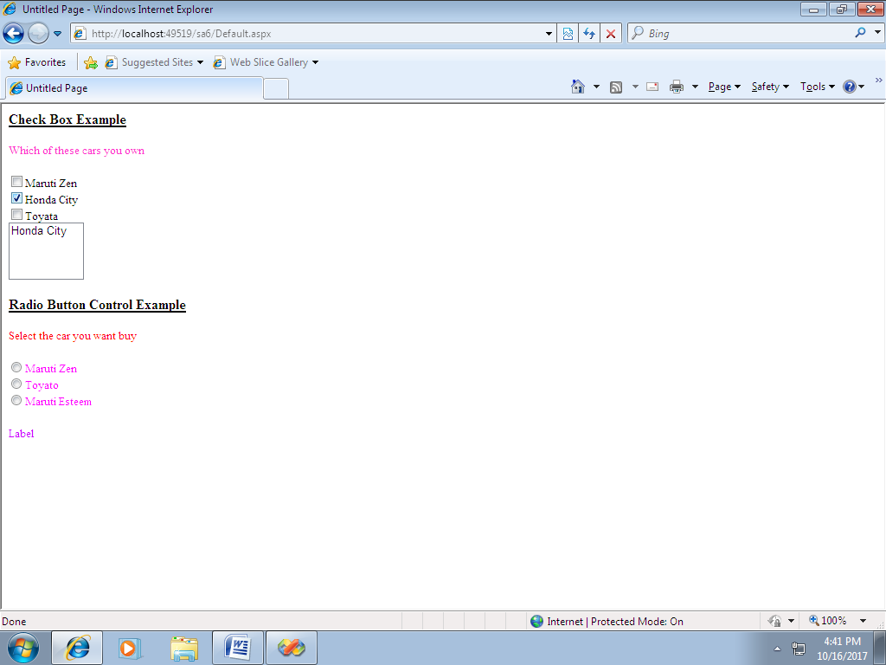

**3]After Clicking Radio Button :-**

